Tên: Nhan Anh Thư
Lớp: CNTT4
MSSV: 1250080190
Bài tập tuần 8

Phiếu 1
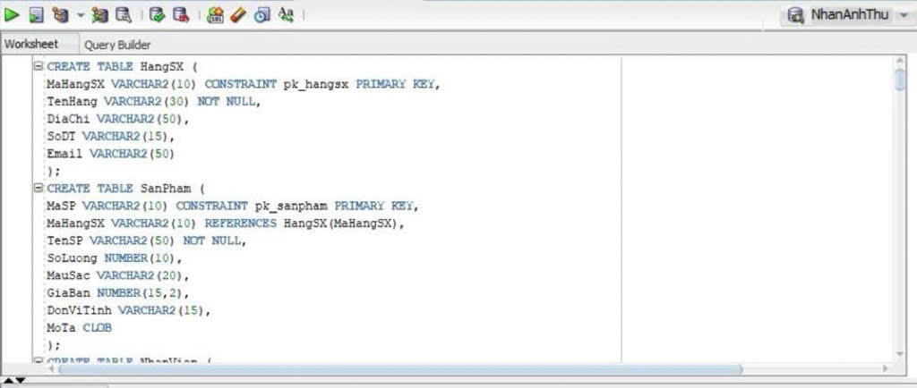
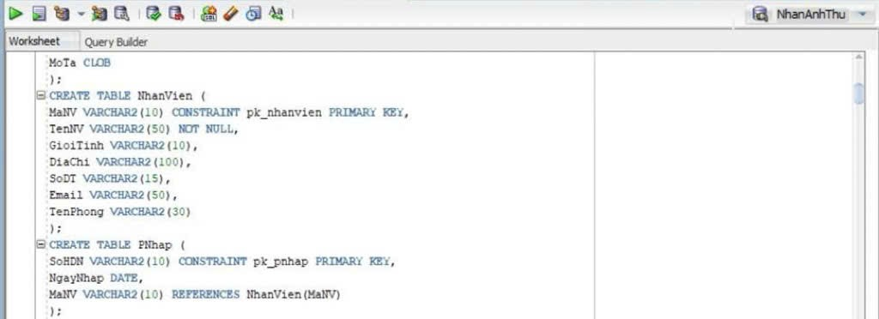
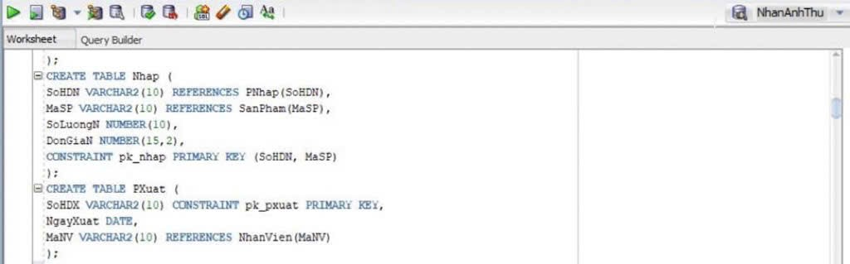
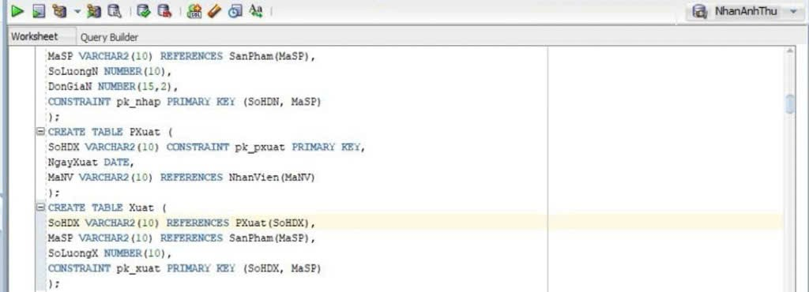
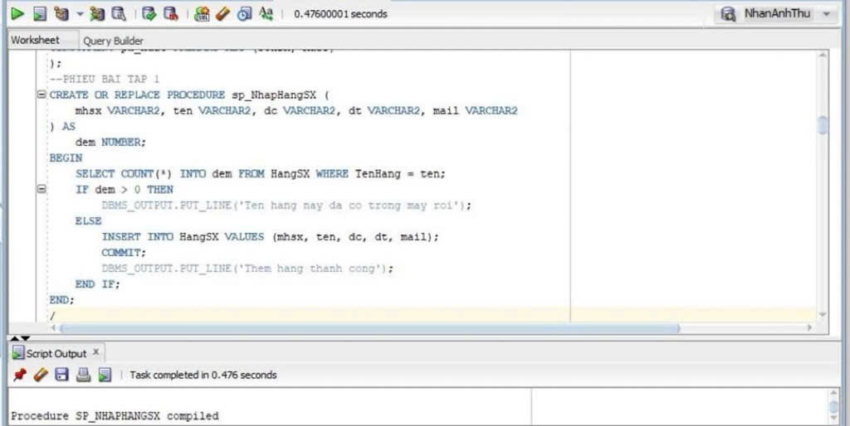
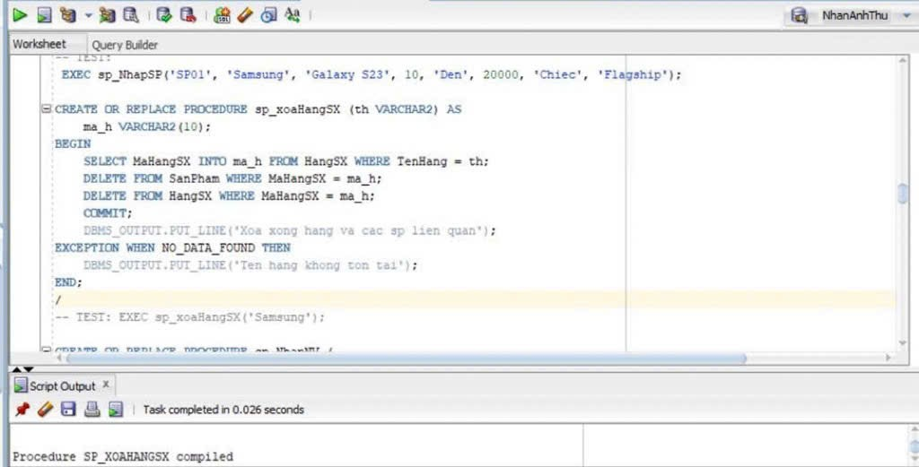
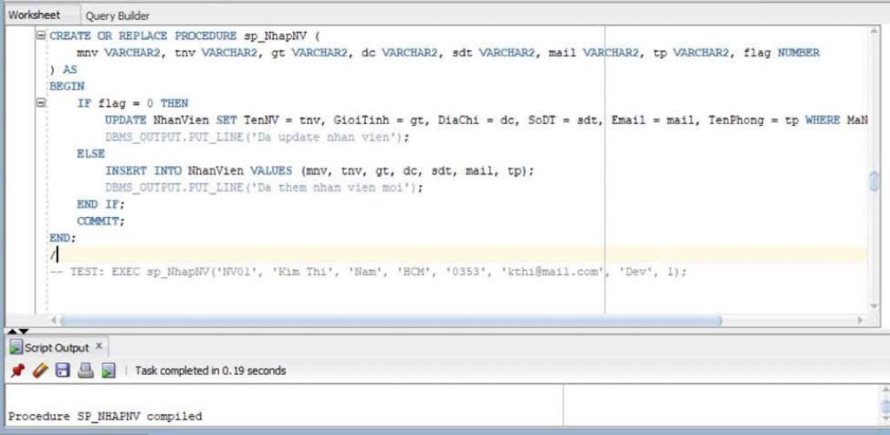
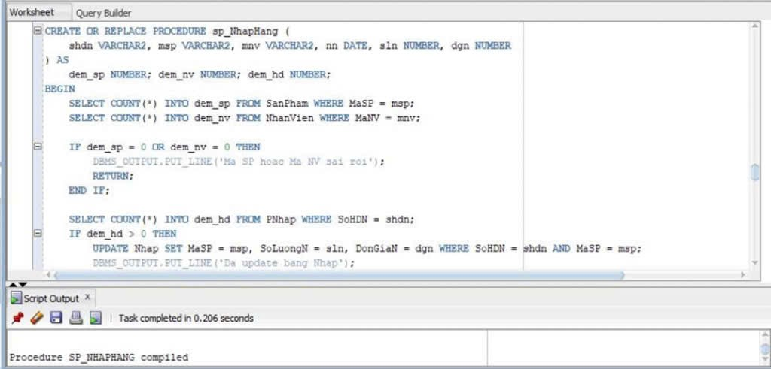
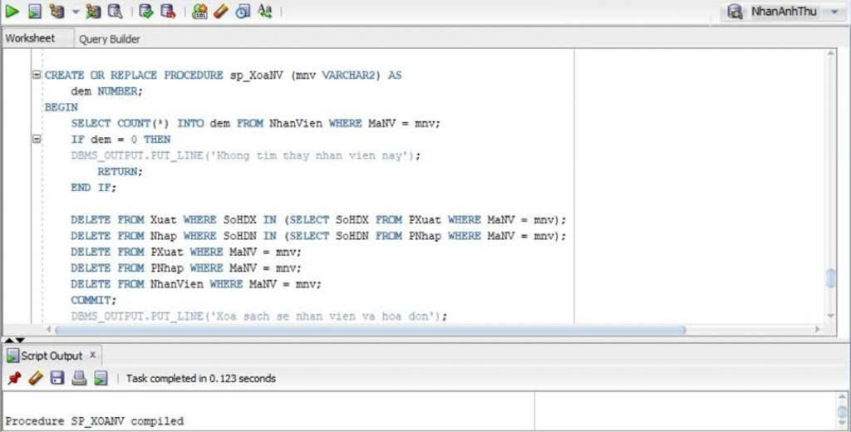

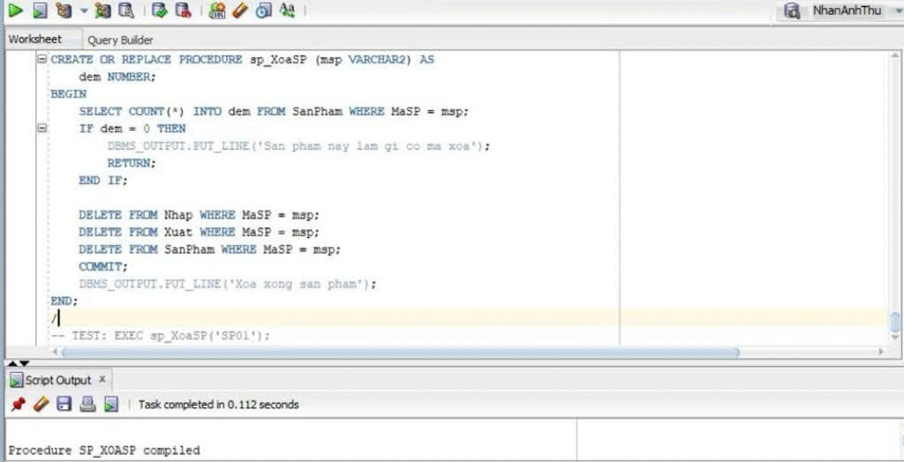
Code bài 1
CREATE TABLE HangSX (

MaHangSX VARCHAR2(10) CONSTRAINT pk_hangsx PRIMARY KEY,
TenHang VARCHAR2(30) NOT NULL,

DiaChi VARCHAR2 (50),

SoDT VARCHAR2 (15),

Email VARCHAR2 (50)

);

CREATE TABLE SanPham (

MaSP VARCHAR2(10) CONSTRAINT pk_sanpham PRIMARY KEY,
MaHangSX VARCHAR2 (10) HangSX (MaHangSX),
TenSP VARCHAR2 (50) NOT NULL,

SoLuong NUMBER(10),

MauSac VARCHAR2 (20),

GiaBan NUMBER(15,2),

DonViTinh VARCHAR2 (15),

MoTa CLOB

);

CREATE TABLE NhanVien (

MaNV VARCHAR2 (10) CONSTRAINT pk_nhanvien PRIMARY KEY,
TenNV VARCHAR2 (50) NOT NULL,

GioiTinh VARCHAR2(10),

DiaChi VARCHAR2 (100),

SoDT VARCHAR2 (15),

Email VARCHAR2(50)

);

CREATE TABLE PNhap (

SoHDN VARCHAR2(10) CONSTRAINT pk_pnhap PRIMARY KEY,
NgayNhap DATE,

MaNV VARCHAR2 (10) REFERENCES NhanVien (MaNV)

);

CREATE TABLE Nhap (

SoHDN VARCHAR2(10) REFERENCES PNhap(SoHDN),
MaSP VARCHAR2 (10) SanPham(MaSP),

SoLuongN NUMBER(10),

DonGiaN NUMBER(15,2),

CONSTRAINT pk_nhap PRIMARY KEY (SoHDN, MaSP)

);

CREATE TABLE PXuat (

SoHDX VARCHAR2(10) CONSTRAINT pk_pxuat PRIMARY KEY,
NgayXuat DATE,

MaNV VARCHAR2 (10) REFERENCES NhanVien (MaNV)

);

CREATE TABLE Xuat (

SoHDX VARCHAR2(10) REFERENCES PXuat (SoHDX),
MaSP VARCHAR2(10) REFERENCES SanPham(MaSP),

SoLuongX NUMBER (10),

CONSTRAINT pk_xuat PRIMARY KEY (SoHDX, MaSP)

);

CREATE OR REPLACE PROCEDURE sp_NhapHangSX (
mhsx VARCHAR2, ten VARCHAR2, dc VARCHAR2, dt VARCHAR2, mail VARCHAR2
) as
dem NUMBER;
BEGIN

SELECT COUNT(*) INTO dem FROM HangSX WHERE TenHang = ten;

IF dem > 0 THEN
DBMS_OUTPUT.PUT_LINE('Ten hang nay da co trong may roi');
ELSE

INSERT INTO HangSX VALUES (mhsx, ten, dc, dt, mail);
COMMIT;

DBMS_OUTPUT.PUT_LINE('Them hang thanh cong');

END IF;

END;
/

CREATE OR REPLACE PROCEDURE sp_xoaHangSX (th VARCHAR2) AS

ma_h VARCHAR2 (10);

BEGIN

SELECT MaHangSX INTO ma_h FROM HangSX WHERE TenHang = th;

DELETE FROM SanPham WHERE MaHangSX = ma_h;

DELETE FROM HangSX WHERE MaHangSX = ma_h;

COMMIT;

DBMS_OUTPUT.PUT_LINE('Xoa xong hang va cac sp lien quan');

EXCEPTION
WHEN NO_DATA_FOUND THEN

DBMS_OUTPUT.PUT_LINE('Ten hang khong ton tai');

END;
/

Phiếu 2
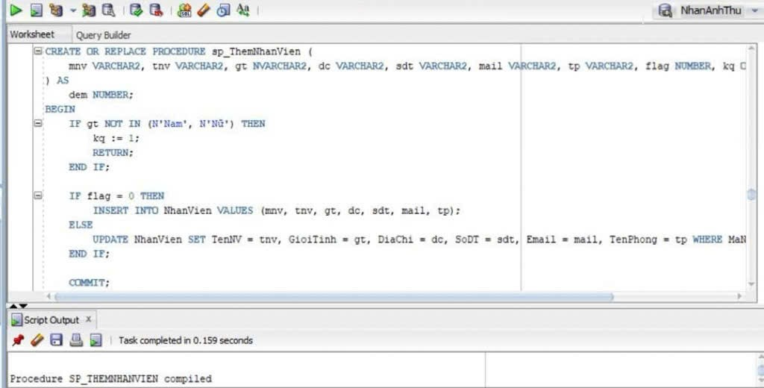
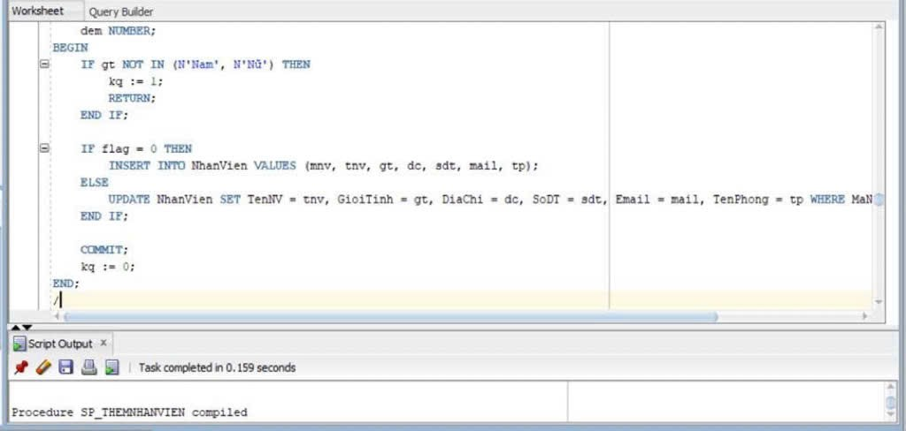
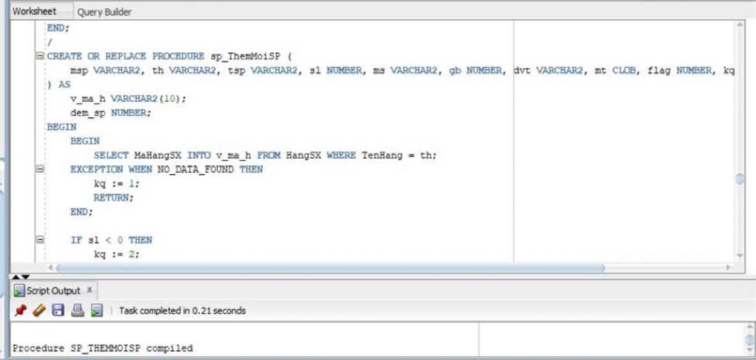
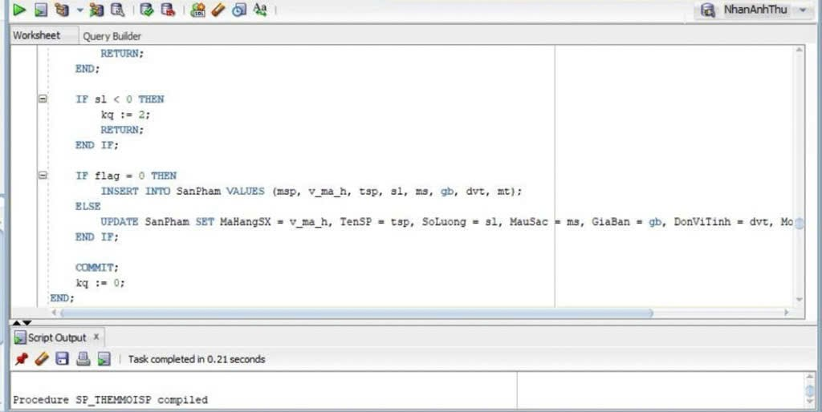
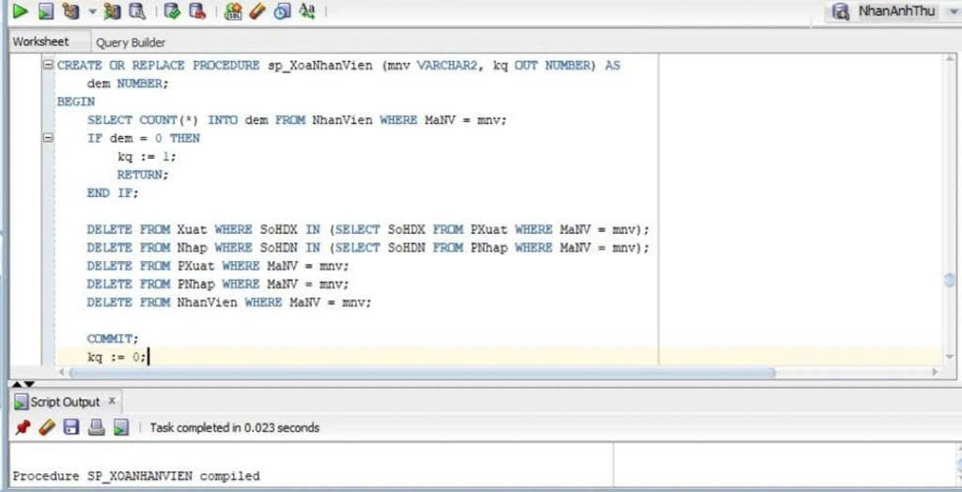
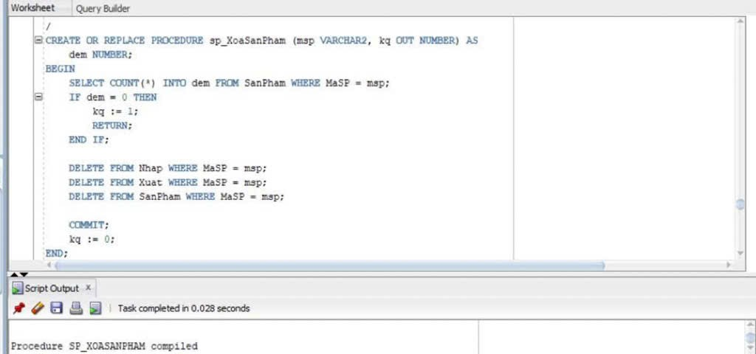
Code phiếu 2
CREATE OR REPLACE PROCEDURE sp_NhapSanPham(
msp VARCHAR2,
mhsx VARCHAR2,
tensp VARCHAR2,
sl NUMBER,
ms VARCHAR2,
gb NUMBER,
dvt VARCHAR2,
mt CLOB
)
AS
dem NUMBER;
BEGIN

SELECT COUNT(*) INTO dem
FROM SanPham
WHERE TenSP = tensp;

IF dem > 0 THEN
DBMS_OUTPUT.PUT_LINE('San pham nay da co roi');

ELSE

INSERT INTO SanPham
VALUES (msp, mhsx, tensp, sl, ms, gb, dvt, mt);

COMMIT;

DBMS_OUTPUT.PUT_LINE('Them san pham thanh cong');

END IF;

END;
/

CREATE OR REPLACE PROCEDURE sp_XoaSanPham(
tensp VARCHAR2
)
AS

msp VARCHAR2(10);

BEGIN

SELECT MaSP INTO msp
FROM SanPham
WHERE TenSP = tensp;

DELETE FROM Nhap
WHERE MaSP = msp;

DELETE FROM Xuat
WHERE MaSP = msp;

DELETE FROM SanPham
WHERE MaSP = msp;

COMMIT;

DBMS_OUTPUT.PUT_LINE('Da xoa san pham va cac du lieu lien quan');

EXCEPTION
WHEN NO_DATA_FOUND THEN

DBMS_OUTPUT.PUT_LINE('San pham khong ton tai');

END;
/

